I put some links to articles that should be relevant to our learning and current project. Feel free to explore them.

1. **Estimate Body Pose Using Deep Learning**

Source: <https://www.mathworks.com/help/deeplearning/ug/estimate-body-pose-using-deep-learning.html>

A pose classifier consists of two sub-tasks (roughly speaking):

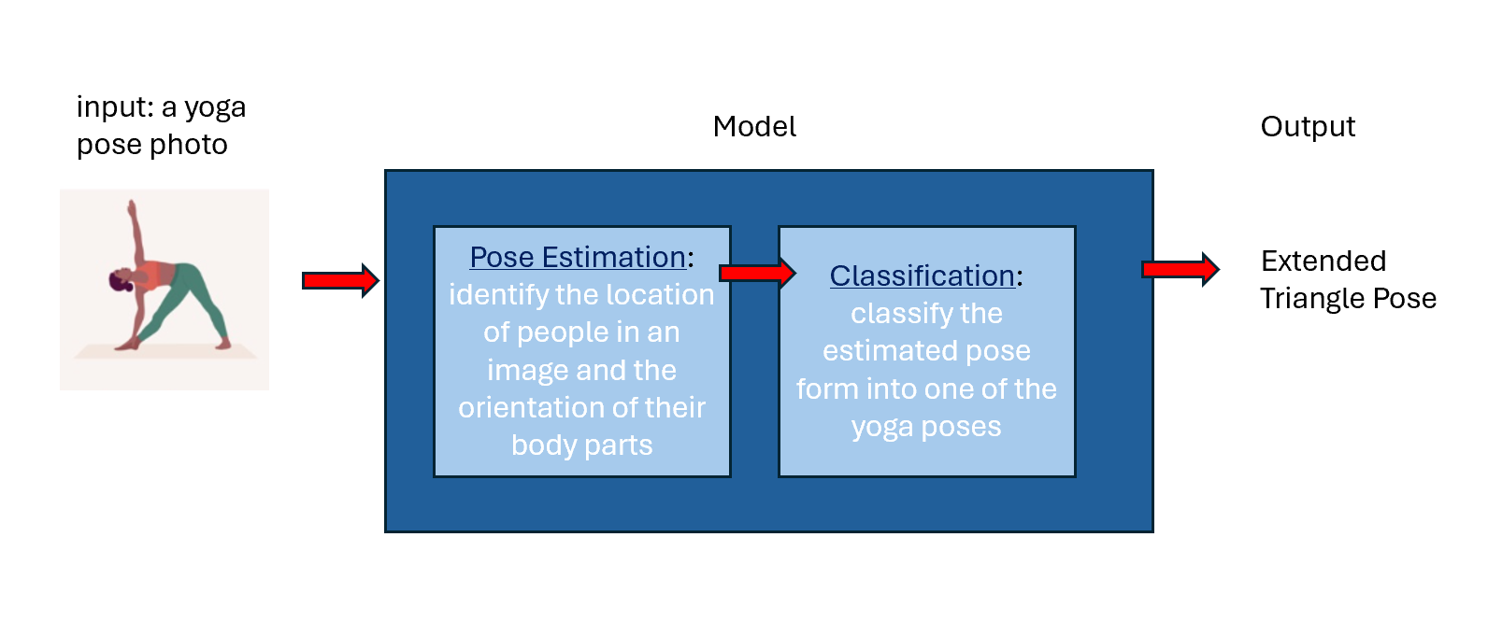

Main takeaway:

* Body pose estimation is the task of “identify[ing] the location of people in an image and the orientation of their body parts”. The output is like this:

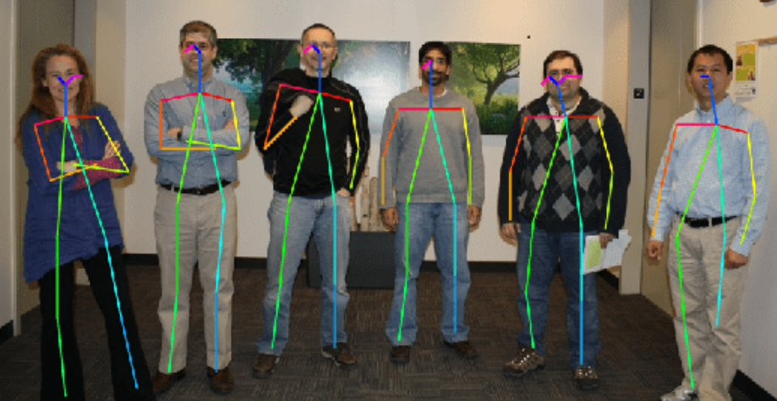

* Pose estimation is most commonly solved using OpenPose, which uses a pretrained neural network. This article gives detailed instructions on how to use OpenPose

2. **Yoga.ai: Deep Learning for Yoga**

Link: <https://cs230.stanford.edu/projects_winter_2019/reports/15813480.pdf>

Main takeaway:

* This is a report by a group of second year stanford students who also did a yoga classification model using deep learning
* What we can do differently:
  + Choose a new architecture to work with
  + Have a larger set of yoga pictures
* Apparently these students were inspired by a blog post, which contains more detail on the development journey
  + Link to blog post: <https://www.amarchenkova.com/posts/convolutional-neural-network-yoga-poses>
  + Link to github repos: <https://github.com/amarchenkova/yoga-pose-CNN/tree/master>
  + In her code, she uses a readily available library called “keras” which already has the CNN architecture setup. For our project, we might be required to define our own CNN using pytorch only

3. **Building powerful image classification models using very little data**

Link: <https://blog.keras.io/building-powerful-image-classification-models-using-very-little-data.html>

Notes:

* I think this article should be relevant to us as we don’t have a big data set
* In the article it is mentioned that Convolution Neural Network “are by design one of the best models available for most "perceptual" problems” → A signal that CNN is our best go for architecture
* It is useful to augment a small data set into larger ones when data collection is very expensive, for example, cancer tumor image
* Data set augmentation is achieved by transforming images: rotation, scaling, mirroring, cropping, etc

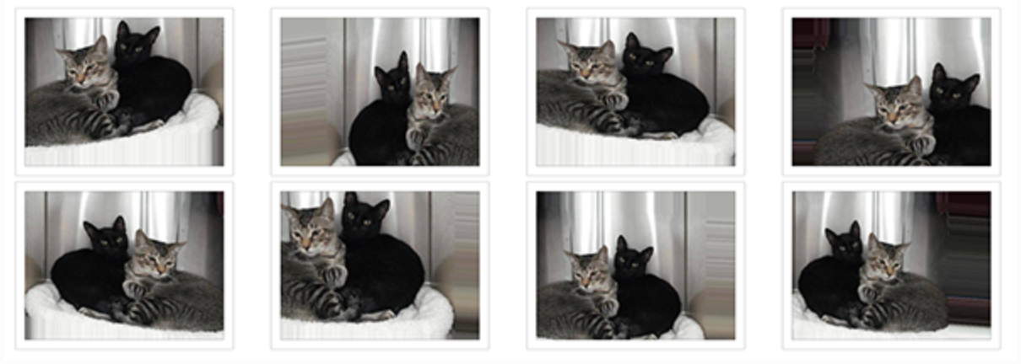

4. **How to Build an Image Classification Dataset**

Link: <https://levity.ai/blog/create-image-classification-dataset>

Main takeaway:

* The usefulness of this article pertains to the rubric: “*We are looking for some effort and evidence of work to collect/repurpose/clean training data vs. simply taking a known dataset*” (from rubric) Especially since we are working on a project that has been done before, our contribution should be that we collected our own data to train a better model
* Number of images should be similar across different classes.
* Criteria for a good data set: diversity, number of images….

5. **What techniques can you use to clean image data for different ML tasks?**

Link: <https://www.linkedin.com/advice/3/what-techniques-can-you-use-clean-image-data-different-fhzsf>

Main takeaway:

* See “Data processing file”

6. **Baseline model**

Link: <https://www.iguazio.com/glossary/baseline-models/>

Main takeaway:

* What is a trained model? First, a machine learning model consists of two things: the mathematical equations (ex, gradient descent) and the training data sets. A trained model is the result of feeding the math equations with datasets such that the coefficients of the math equations can be determined.
* A baseline serves as a point of reference against which the performance of more advanced models is measured

Some links to cleaning dataset:

* <https://www.linkedin.com/advice/3/what-techniques-can-you-use-clean-image-data-different-fhzsf>
* <https://aidancoco.medium.com/data-cleaning-for-image-classification-de9439ac1075>
* <https://joelnadarai.medium.com/cleaning-image-dataset-a-step-by-step-tutorial-with-fastdup-using-kaggle-a4d30afb4a5c>